**Low Level Design:**

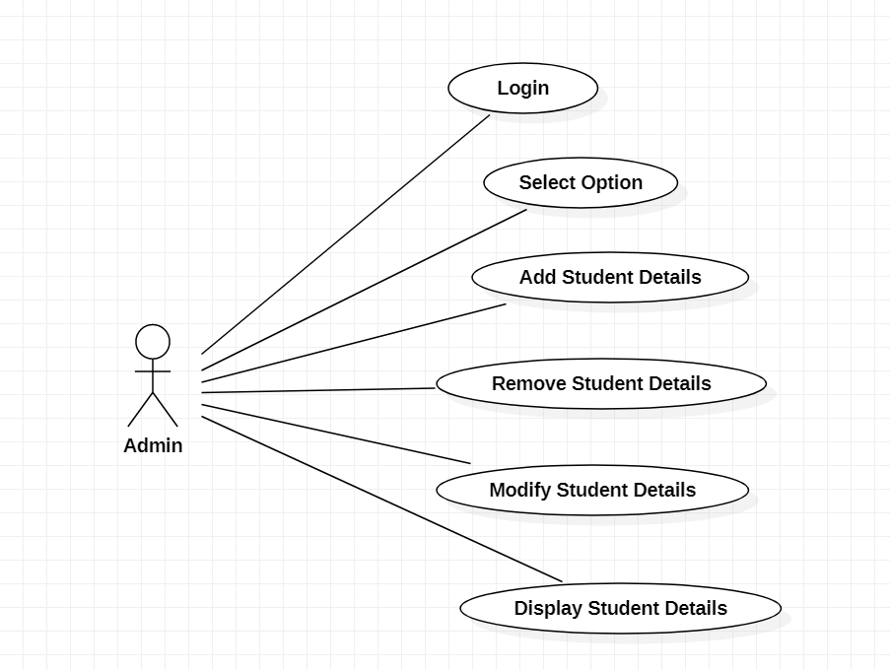

* The project is “School Management System” of “Delhi Public School”.
* The objective of the project is to maintain records of the students.
* The software adds the details of the student and displays it.
* First the user is supposed to enter it’s user name and password on the application and then the application gets connected to the compiler .
* The compiler then responds whether the username and password that the user entered is correct or not.
* The application asks the user to choose options like to add ,modify or remove details.
* If the user doesn’t select an appropriate option then an exception would occur that “please choose a valid option”.
* Else the user is supposed to enter it’s details on the application
* The application then gets connected with the compiler.